**Chalique nail studio information system**

**VERIFICATION TESTING**

**ITRW 225 – Systems Analysis & Design**

## Input data in system:

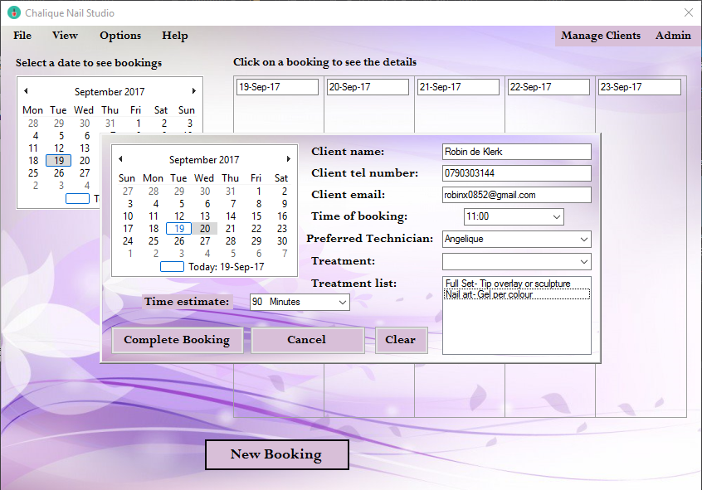

## Verify data in bookings:

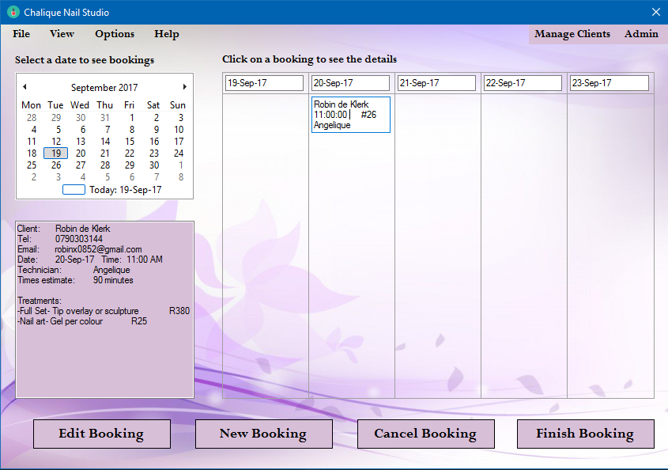

## Case 2 Verify Input:

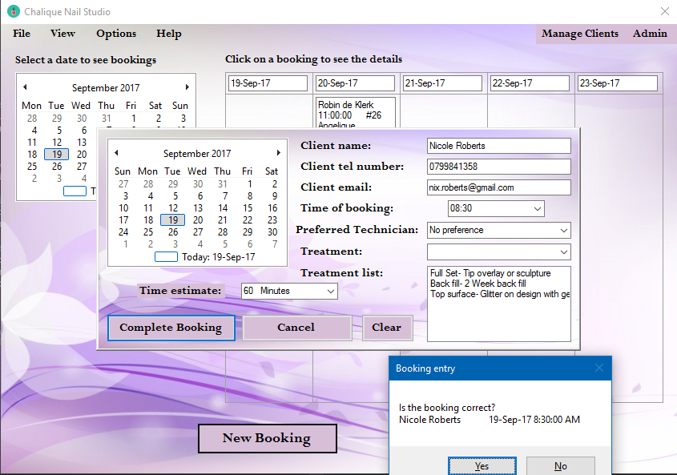

## Case 2 Verify data in Bookings:

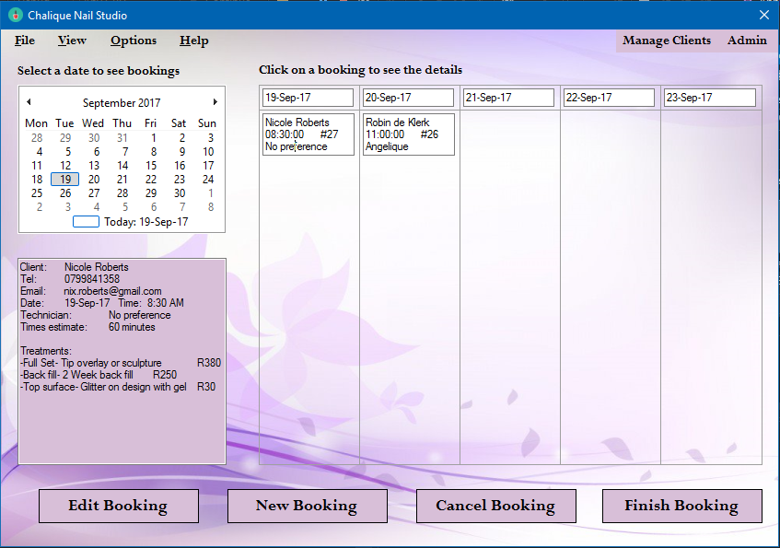

## Verify data while Finalising a booking and making payment:

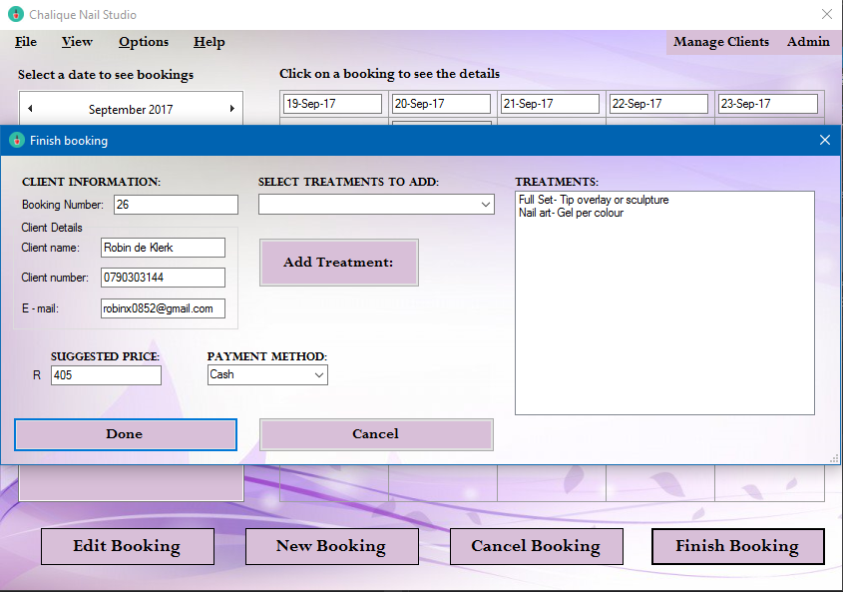

## Case 2 Verify data while Finalising a booking:

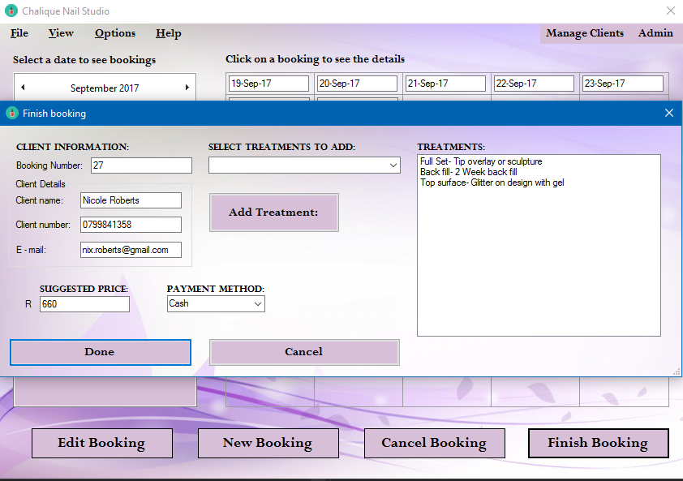

## Input new Operational Expense:

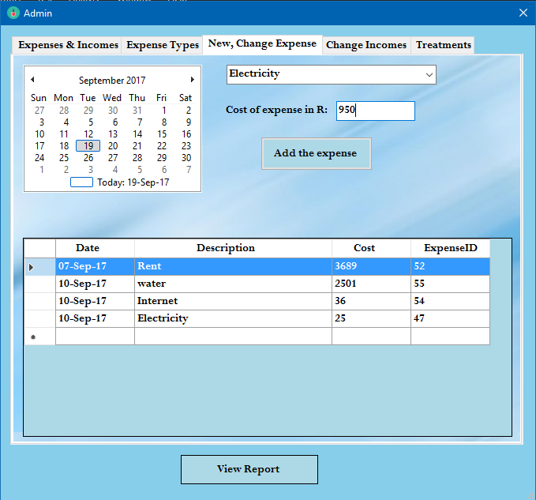

## Case 2 Input new Operational Expense:

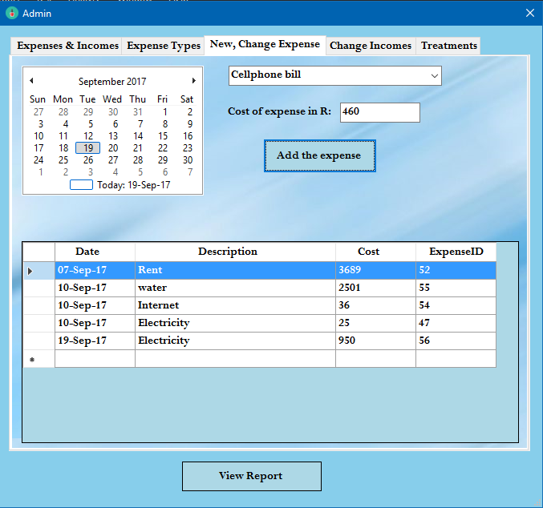

## Verify data in Incomes and expenses list:

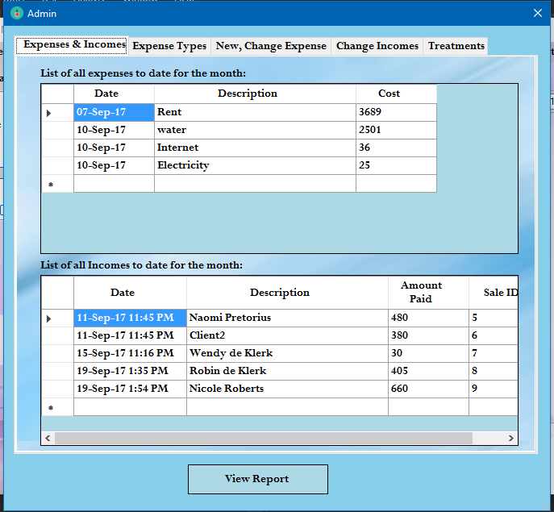

## Verify data in the Report:

